Guide to BLCU 2021 Spring Online Chinese Language Programs
I. One-year Online Refresher Chinese Courses
1. Tuition Fee and Dates of Courses
Study Duration  (Beijing time: Monday-Friday) | Tuition (RMB) | Deadline of  Application
Mar.1 2021 - mid-Jan. 2022 (one academic year) | 25800 | Jan.15 2021

2. Curriculum
A wide variety of courses are offered, including:
- Elementary to advanced Chinese courses
- Advanced Training Course (Chinese Special Studies)
- Teacher Training Course
- HSK 1-6 Course

3. Methods of course delivery
We will use a combination of three methods:
- Live streaming:
Use the live streaming platform and software for online teaching, real-time interaction between teachers and students, and instant feedback of questions. Each live lesson has a video of the course, and students can watch the video within the specified time. Each course has two live streaming sessions, and students in different time zones can choose the time that suits them.

Available Study Duration | Beijing Time
Duration A | 8:00-10:00
Duration B | 16:00-18:00

- Recording method: Click the URL link of the teaching platform or video website to watch and learn the course video. Course videos can be played repeatedly and paused at any time, and students can arrange their learning time independently. Course videos can be played on the mobile client, which is convenient for students to learn in different places and using fragmented time.

- Live streaming + recording method: Students can learn the contents of the recorded and live streaming lessons by themselves, and then participate in the live broadcast lessons, follow the teacher on-site practice, and communicate with classmates in real time.

II. Short-term Chinese online course
I. Five highlights of our programs
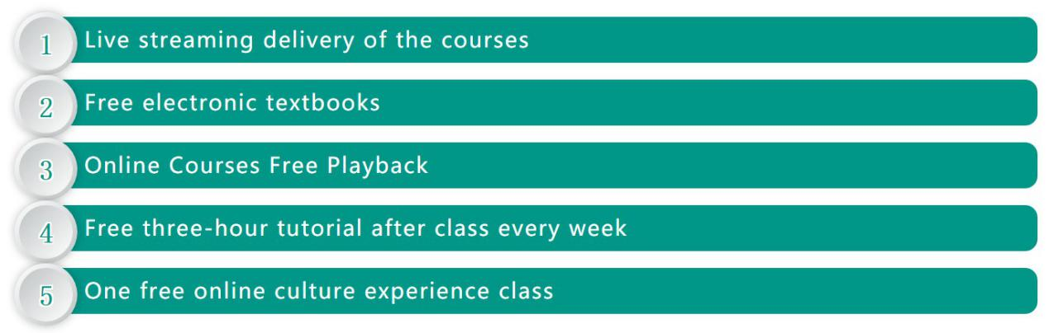
Ⅱ. Platforms and software
VooV Meeting
（Download at https://voovmeeting.com）
WeChat
（Download at https://weixin.qq.com）
Ding talk
（Download at https://www.dingtalk.com）

III. Tuition Fee and Dates of Courses
1. Regular Chinese Courses
No. | Study Duration  (Beijing time: Monday-Friday) | Classes/Weeks | Tuition  (RMB) | Deadline of Application
1 | Feb.25—Jun.4 （8:30-12:30） | 280 classes /14-week | 11000 | Feb.19
2 | Feb.25—Jun.4 （18:00-21:50） | 280 classes /14-week | 11000 | Feb.19
3 | Feb.25—Mar.24 （8:30-12:30） | 80classes /4-week | 4000 | Feb.19
4 | Feb.25—Mar.24 （18:00-21:50） | 80classes /4-week | 4000 | Feb.19
5 | Mar.25—Apr.22 （8:30-12:30） | 80classes /4-week | 4000 | Mar.19
6 | Mar.25—Apr.22 （18:00-21:50） | 80classes /4-week | 4000 | Mar.19
7 | Apr.23—Jun.4 （8:30-12:30） | 120classes /6-week | 5600 | Apr.17
8 | Apr.23—Jun.4 （18:00-21:50） | 120classes /6-week | 5600 | Apr.17
No. | Study Duration  (Beijing time: Mon., Wed., Fri.) | Classes/Weeks | Tuition  (RMB) | Deadline of Application
1 | Feb.26—Jun.7 （19:00-20:50） | 84 classes /14-week | 4200 | Feb.20
2 | Feb.26—Mar.24 （19:00-20:50） | 24 classes/4-week | 1500 | Feb.20
3 | Mar.26—Apr.23 （19:00-20:50） | 24 classes/4-week | 1500 | Mar.20
4 | Apr.26—Jun.7 （19:00-20:50） | 36classes /6-week | 2200 | Apr.20

2. Business Chinese Course (HSK4 or equivalent is required)
No. | Study Duration  (Beijing time: Mon., Wed., Fri.) | Classes/Weeks | Tuition  (RMB) | Deadline of Application
1 | Feb.26—Jun.7 （19:00-20:50） | 84 classes /14-week | 7500 | Feb.20
2 | Feb.26—Mar.24 （19:00-20:50） | 24 classes/4-week | 2400 | Feb.20
3 | Mar.26—Apr.23 （19:00-20:50） | 24 classes/4-week | 2400 | Mar.20
4 | Apr.26—Jun.7 （19:00-20:50） | 36classes /6-week | 3600 | Apr.20

3. China Panorama (HSK4 or equivalent is required)
No. | Study Duration  (Beijing time: Tues., Thur., Sat.) | Classes/Weeks | Tuition  (RMB) | Deadline of Application
1 | Feb.25—Mar.23 （19:00-20:50） | 24 classes/4-week | 2400 | Feb.19
2 | Mar.25—Apr.20 （19:00-20:50） | 24 classes/4-week | 2400 | Mar.19
3 | Apr.22—May.20 （19:00-20:50） | 24 classes/4-week | 2400 | Apr.16
(Note: April 5th is the Ching Ming Festival holiday, and May 3 is the Labor Day holiday）
4. Customized Courses for individuals or groups
We can offer a series of online courses such as Chinese language, Chinese culture, and Chinese studies all year round according to you and your students’ needs. The curriculum can be customized accordingly and delivered on a flexible schedule. We also designed a variety of online cultural experience activities. Please feel free to contact me should you have any questions.

IV. Procedures

- How to apply
Option 1：Online application system http://lxs.blcu.edu.cn/StusSystem/login.do?text=en
Option 2：Send the following documents to us by email:
① BLCU Online Program Application Form for International Students
（Download at http://admission.blcu.edu.cn/en/xzzx/list.htm）
② Photocopy of passport homepage
Email：zhaosh2@blcu.edu.cn (for Regular Chinese Courses)；
admissions1@blcu.edu.cn
(for Business Chinese Course and China Panorama)
③ The proof of application fee payment
- Online courses application fee: 300 RMB per person. The online teaching is not limited to any region, but we cannot resolve visa issues for you.
- Payment methods
- You can pay application fee online through our website (http://admission.blcu.edu.cn).
- If you are out of the country, please make a bank wire transfer to (accept foreign currency, converted at the bank's real-time exchange rate)
ACCOUNT WITH BANK： HUA XIA BANK, BEIJING BRANCH
SWIFT BIC： HXBKCNBJ030
A/C NO： 4066200001819400000429
NAME： BEIJING LANGUAGE AND CULTURE UNIVERSITY
ADDRESS： 15THXUEYUAN ROAD, HAIDIAN DISTRICT, BEIJING, CHINA
- In China, you can wire transfer direct to:
NAME: 北京语言大学
A/C NO: 0200006209089106391
ACCOUNT BANK: 中国工商银行北京东升路支行
2. Placement test
You will receive your registration number and a link to take a placement test by email.
(Note: Please download Wechat and register for a Wechat account before taking the placement test.)
Please click on the link http://admission.blcu.edu.cn/spzx/list.htm to view videos of the different levels of demo classes.

3. Tuition fee payment
Pay tuition fee and send the payment proof to us by email (Screenshot of your WeChat or Alipay payment can be used as proof as well).
For specific information about how to pay, please refer to BLCU Online Program Application Form for International Students or website:
http://admission.blcu.edu.cn/en/xzzx/list.htm
4. Taking classes
After receiving the confirmation email of your payment, you can join the class.
(Note: The course will be provided on the basis of at least 10 students in one class after the adjustment of classes)

V. Award Certificate
According to the study duration and final test results, BLCU will provide a Course Learning Certificate and transcripts for short-term Chinese courses. The original cooperation programs will be switched to online teaching and credits will still be certified.

VI. Contacts
International Admissions Department,
Beijing Language and Culture University
Tel: 0086-10-82303951；0086-10-82303086；0086-10-82303088
Email: zhaosh2@blcu.edu.cn (for Regular Chinese Courses)
admissions1@blcu.edu.cn (for Business Chinese Course and China Panorama)
Website: admission.blcu.edu.cn

